1. Use start.bat to startu Nulstar on Windows, all deployed modules are startup, and port 8089 is open.





1. Use Postman to send http POST to Connector for “ListApi” request.

1]Send malformed Request message, Connector is crashed. Report github issue <https://github.com/CCC-NULS/Nulstar/issues/6>.

**Malformed Request message:**

{"MessageData":{"RequestAck":"0","RequestMethods":{"ListAPI":null},"ResponseMaxSize":"0","SubscriptionEventCounter":"0","SubscriptionPeriod":"0","SubscriptionRange":""},"MessageID":"1559699289509","MessageType":"Request","TimeZone:8,"Timestamp":1559699302853}

2] Send correct Request message, Postman could receive Response from Connector.

**Correct Request message:**

{"MessageData":{"RequestAck":"0","RequestMethods":{"ListAPI":null},"ResponseMaxSize":"0","SubscriptionEventCounter":"0","SubscriptionPeriod":"0","SubscriptionRange":""},"MessageID":"1559699289509","MessageType":"Request","TimeZone":8,"Timestamp":1559699302853}

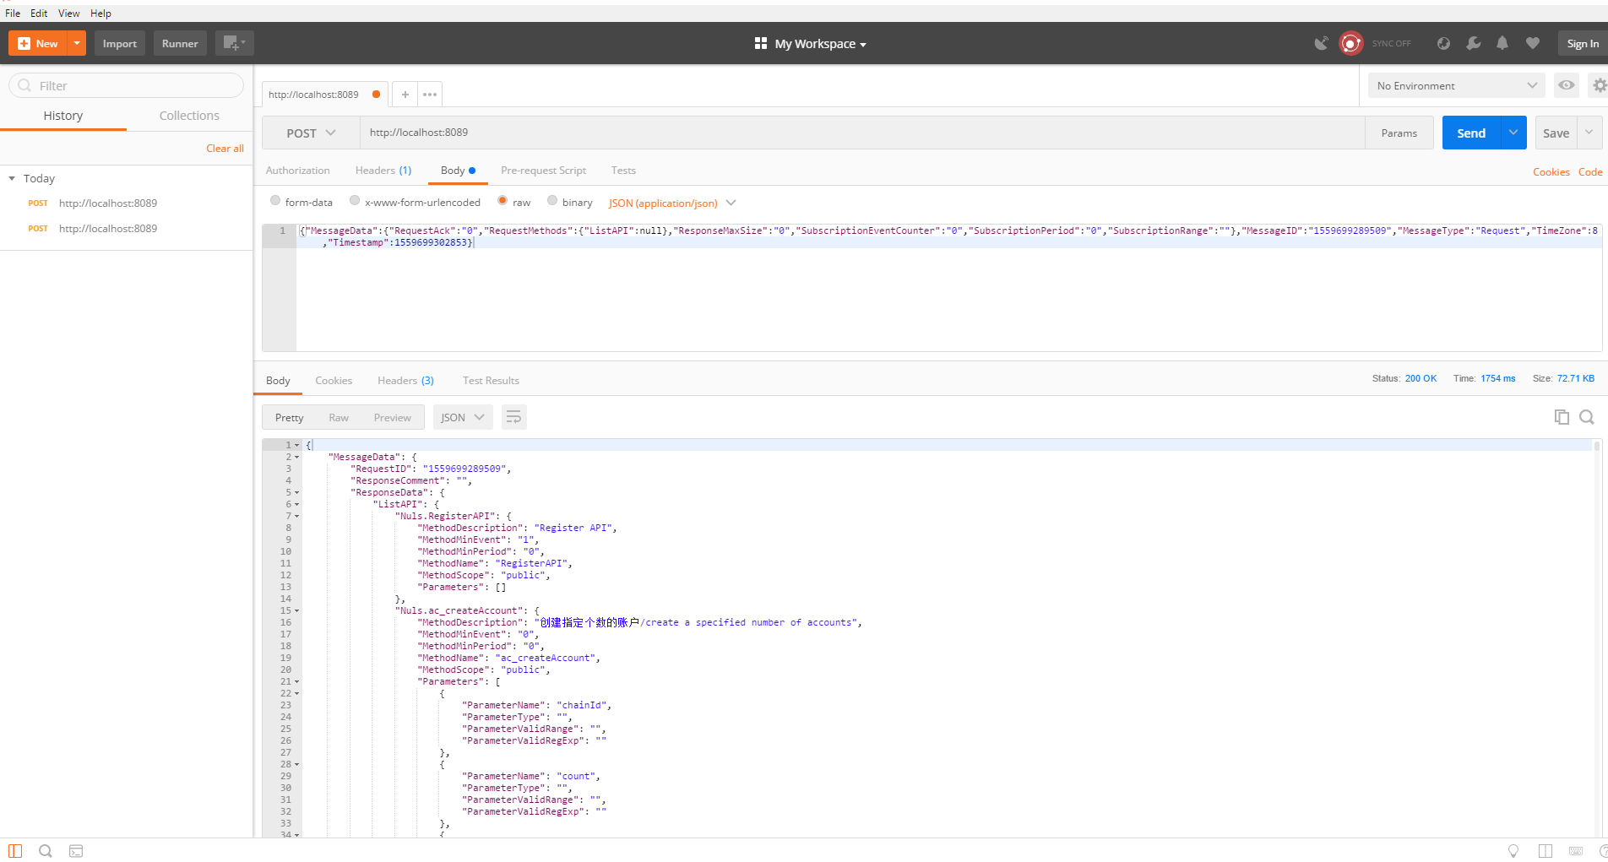

3] After 1] issue was fixed, to send malformed Request message to port 8089, Postman could receive Response from Connector, which indicates message format incorrect.

**Malformed Request message:**

{"MessageData":{"RequestAck":"0","RequestMethods":{"ListAPI":null},"ResponseMaxSize":"0","SubscriptionEventCounter":"0","SubscriptionPeriod":"0","SubscriptionRange":""},"MessageID":"1559699289509","MessageType":"Request","TimeZone:8,"Timestamp":1559699302853}

**Received Response message:**

{"MessageData":{"RequestID":"0","ResponseComment":"Message is not in JSon format!","ResponseData":{"":{}},"ResponseErrorCode":"NCN-5","ResponseMaxSize":"0","ResponseProcessingTime":"0","ResponseStatus":5},"MessageID":"1565145798720-5","MessageType":"Response","TimeZone":"8","Timestamp":"1565146428600"}